**Activity: Apply a pivot**

[Product-Color Model](https://d3c33hcgiwev3.cloudfront.net/nA6hz9mlQzO7VQVjtZAaxw_cff1f963876a4fff91e09afc8a49d9e1_Product-Color-Model.xlsx?Expires=1709769600&Signature=WaQBjgzWX6nmBrz4OLUoC3UZbuhXoLzZ9N820Q3~4r8Drap4DvnGMM3TPrDamrW82lBP8vmfLBTitQD3k4AkFocxI2v3qteZ9q0Z0y1eI~t~7YAE4dSWQsGGMNFzYu6MCBzKEwOgYYJyvClXIg6MpErPrtoX8jGg0Vj6SVRyZak_&Key-Pair-Id=APKAJLTNE6QMUY6HBC5A" \t "_blank)

[XLSX File](https://d3c33hcgiwev3.cloudfront.net/nA6hz9mlQzO7VQVjtZAaxw_cff1f963876a4fff91e09afc8a49d9e1_Product-Color-Model.xlsx?Expires=1709769600&Signature=WaQBjgzWX6nmBrz4OLUoC3UZbuhXoLzZ9N820Q3~4r8Drap4DvnGMM3TPrDamrW82lBP8vmfLBTitQD3k4AkFocxI2v3qteZ9q0Z0y1eI~t~7YAE4dSWQsGGMNFzYu6MCBzKEwOgYYJyvClXIg6MpErPrtoX8jGg0Vj6SVRyZak_&Key-Pair-Id=APKAJLTNE6QMUY6HBC5A" \t "_blank)

**Introduction**

So far, you’ve learned that it’s challenging to identify patterns within unstructured flat data that lacks organization or grouping. Using Power Query, you can transform your flat data into a structured tabular format, aggregating values for each unique value in a designated column. Power Query conducts grouping and aggregate calculations for every individual value in the column, and then pivots the column into a new table, the transformation enabling you to structure your data and analyze it more effectively. In this step-by-step activity, you’ll gain hands-on experience in applying the pivot operation in Power BI.

**Apply a pivot**

In this activity, you will convert an Adventure Works Excel file called *Product-Color Model.xlsx* that includes Product ID, Color, and Model data. You need to present the product count per color in a tabular format. To do this, you need to import the Excel data first and then pivot columns by using aggregate functions. Follow the steps below to apply a pivot in Power BI.

**Step 1: Select the data source type**

1. Open **Power BI Desktop**.
2. On the Home ribbon tab, inside the Data group, select the **Get Data** down arrow followed by **Excel** to find *Product-Color Model.xlsx.*

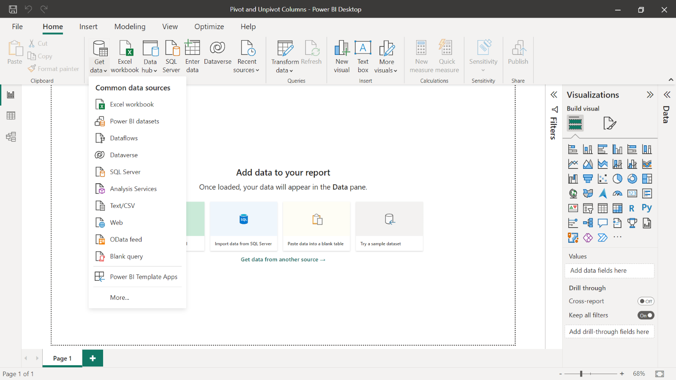

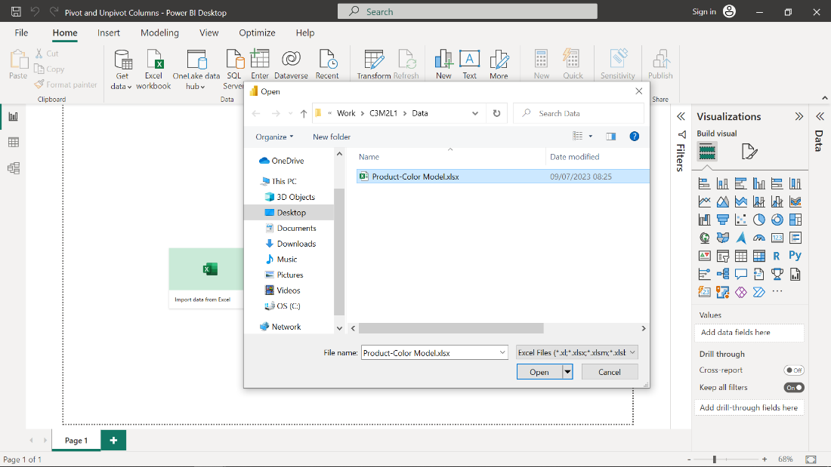

**Step 2: Import Excel data**

1. Import the **Excel data** to add the **Product-Color** **Model** query to the Queries pane.
2. Observe the 3 columns in the table: **Product Name, Color** and **Model**.
3. Remove the **Product Name** column. **Note:** Because your objective is to present the product count by color, you do not need this column.

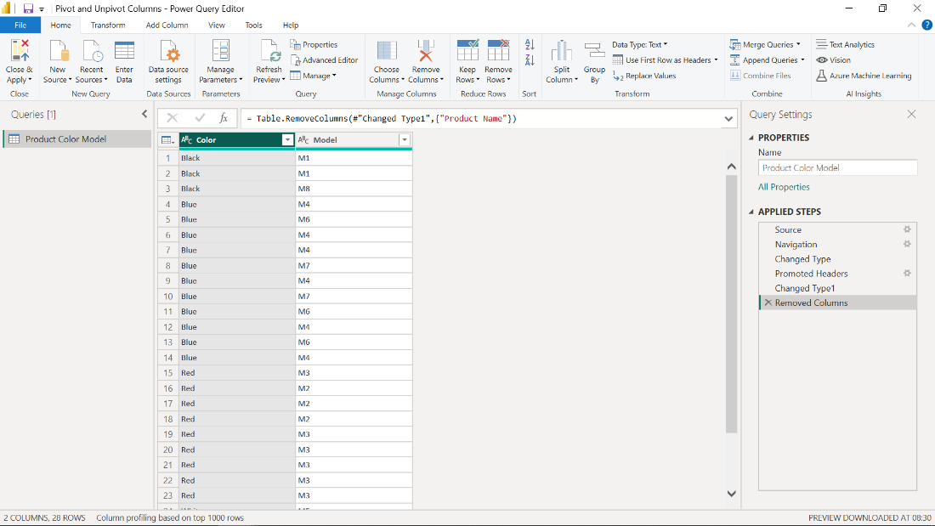

**Step 3: Pivot columns**

1. To pivot the table columns, select the **Product-Color Model** query on the left menu.
2. Select the **Transform ribbon** tab, followed by **Pivot Column**.

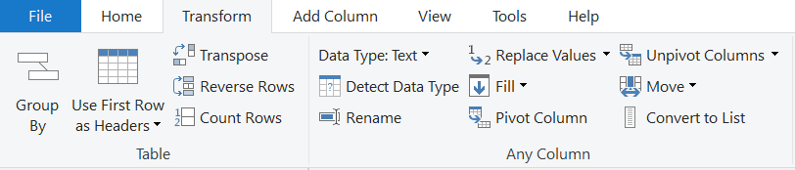

1. On the **Pivot Column** window that displays, select the **Color** column in the query and keep the value in **Values** column dropdown list.
2. Expand the **Advanced options** and select option **Count (All)** from the **Aggregate Value Function** dropdown list, and then select **OK**.

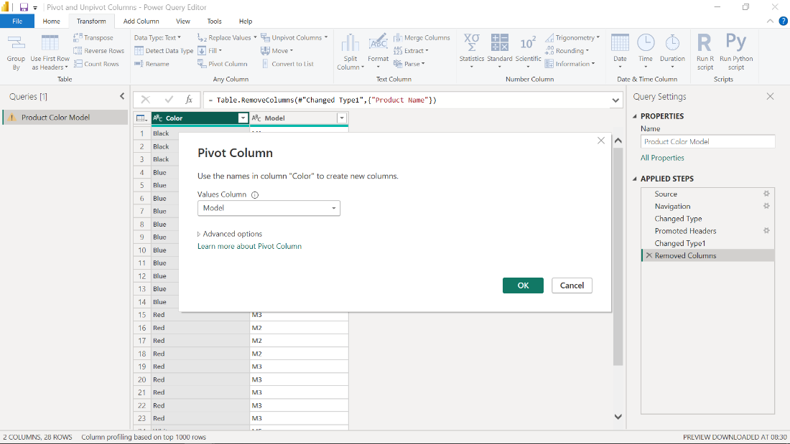

**Note: Count** is an aggregate function and **Count(All)** counts every row and returns an integer value. Generally, it's recommended to use **Count** as the aggregate function. In some cases, you may use **SUM**, which calculates the summation of all the rows. MIN, MAX or AVG functions are rarely used.

**Step 4: Examine the changes**

By applying the **Pivot Column**, you change the way the data is organized. All distinct color values are converted to the column headers. There is just one row in the table, where every column has a matching count of that category in the previous rows. You can use this data to visualize in reports or dashboards, primarily in pie chart reports.

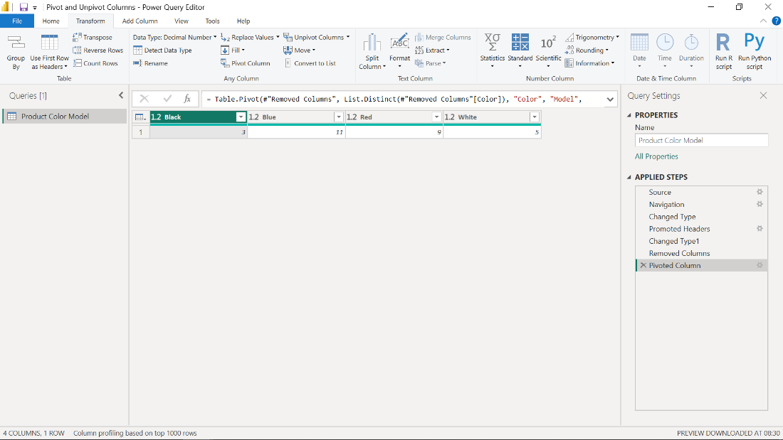

**Conclusion**

In this step-by-step activity, you practiced applying a pivot operation in Power BI — an important operation especially when working with Excel data. You observed that the pivot operation converts row values to columns and sets aggregate function results for the column rows. Remember that both pivoting and unpivoting operations are useful where you need rows converted to columns and columns converted to rows respectively. Now that you’ve applied the pivoting technique, you’re better prepared to use them in a data analysis task.